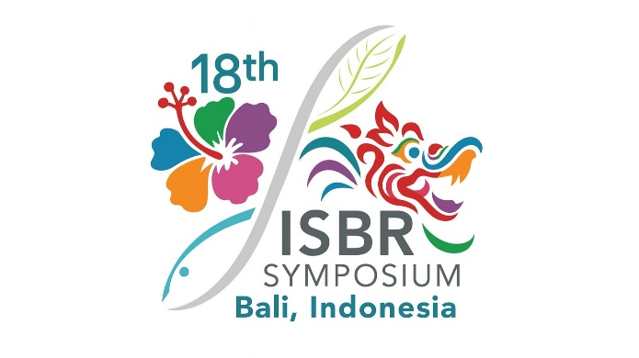

PROPOSAL SUBMISSION TEMPLATE
WORKSHOP

Parties interested in organizing a workshop at ISBR2027 are invited to complete and submit this application form. Workshops will be 3 hours in duration, with flexibility in format to accommodate a range of approaches, including interactive sessions, presentations, panel discussions, case studies, and other participatory activities.
Instructions
- Download and complete this template, then submit it by email to admin@isbr.info with the subject line "WORKSHOP PROPOSAL"
- Proposals are due November 15th, 2026.

Proposed workshop title
Name, email address, and affiliation of organizer(s)
Abstract describing the workshop topic and its relevance to the ISBR2027 theme (max 300 words)
Proposed workshop chair/facilitators
Proposed agenda outline
Activity type  (talk, discussion, exercise, etc.) | Facilitator(s)/Participant(s) | Title/Topic/Content |  | Time (min)
Please acknowledge the following
Do you agree to strive for diversity (gender, race, nationality, etc.) across the facilitators/speakers in your workshop? |  |  | Yes |  | No
Do you acknowledge that there is no funding to support the registration, travel, or accommodations for workshop organizers/facilitators/speakers in your session? |  |  | Yes |  | No
Please specify any logistical considerations for your workshop below.
For example, do you need the room set up with tables for interactive discussion or with auditorium seating? Do you need participants to bring laptops for an interactive session?

