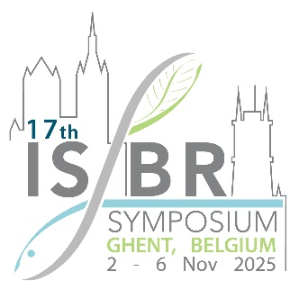

**PROPOSAL SUBMISSION TEMPLATE**

**TOPIC-SPECIFIC PARALLEL SESSION**

Parties interested in organizing a topic-specific parallel session should complete and submit this application form. Parallel sessions will be 1.5 hours in duration, with 5 speakers (15 minute presentations).

**Proposals are due December 15th 2024**

|  |  |  |  |
| --- | --- | --- | --- |
| **Proposed title for** **topic-specific parallel session** | | | |
|  | | | |
| **Name, email address and affiliation of organizer(s)** | | | |
|  | | | |
| **Abstract describing the session topic and its relevance to the ISBR2025 theme** (max 300 words) | | | |
|  | | | |
| **Proposed session chair** | | | |
|  | | | |
| **Proposed speakers and presentation titles/content** | | | |
| Introduction (5 min) |  | | |
| Speaker 1 (15 min) |  | | |
| Speaker 2 (15 min) |  | | |
| Speaker 3 (15 min) |  | | |
| Speaker 4 (15 min) |  | | |
| Speaker 5 (15 min) |  | | |
| Discussion & wrap up  (10 min) |  | | |
| **Please acknowledge the following** | | | |
| Do you agree to strive for diversity (gender, race, nationality, etc.) across the speakers in your session? | | **Yes** | **No** |
|  |  |
| Do you acknowledge that there is no funding to support the registration, travel, or accommodations for the session chair and/or the speakers in your session? | | **Yes** | **No** |
|  |  |

**Please note: Download the forms, fill in, save, attach and email to the** [**ISBR Symposium Secretariat**](mailto:ISBRsymposium@allevents.co.za?subject=TOPIC-SPECIFIC%20PARALLEL%20SESSION%20PROPOSAL)**with the subject line: PROPOSAL SUBMISSION TEMPLATE TOPIC-SPECIFIC PARALLEL SESSION.**