**ISBR 2025 Exhibition packages**

The International Society for Biosafety Research (ISBR) offers companies an opportunity to exhibit at the ISBR Symposium to be held from 2nd November to 6 November 2025 at the ICC, Ghent, Belgium. The booths are draped structures and no shell scheme structures or custom-built stands are permitted. The structures will be erected on the morning of Sunday, 2nd November and will be ready for exhibitors to move in at 14:00am that day to dress their stands (Pull up banners are advised). All teas and lunches will be held in the exhibition area (First floor). On Sunday evening we will be hosting the welcome reception in the same area and you would need to be set up by 17:00. A perfect opportunity to network and discuss opportunities to collaborate and share experiences and insights.

**Exhibition rates**

Regular Rate - $1,300 per booth

January 15, 2025 – March 31 , 2025

 Late Registration Rate - $1,600 per booth

After March 31 (from 1 April), 2025

 Additional Booth Personnel Registration - $850

All Exhibit Booths include one (1) Exhibit Booth Personnel Registrations (can be used by paper presenters to attend the symposium). Organizations can purchase additional Personnel Registrations if needed at an additional charge of $850.

Each Exhibit Booth Rental includes:

* One (1) fabric booth (please refer to the diagram with the dimensions)
* One (1) skirted table and one wastebasket
* One (1) organization identification sign
* Two (2) plastic side chairs
* One (1) Exhibitor personnel Symposium registration which can be used as an attendee registration.
* Organization logo and listing on the Symposium website with link to company’s website.

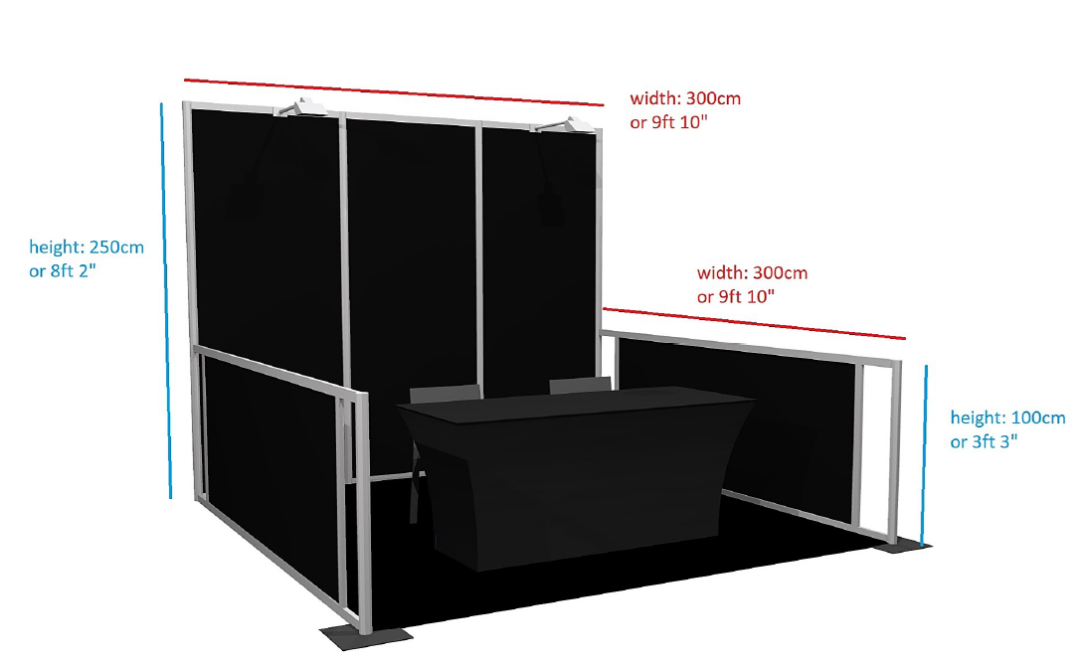

**To book, please email Crystal on** [**crystal@centeqevents.co.za**](mailto:crystal@centeqevents.co.za)